Dear Parent/Carer,

The administration of medication in school

St Michael’s understands that there are occasions where pupils require medication during school hours, and we are happy to support you and your child whenever possible in these instances. In order to ensure the safe administration of medication to your child please read the following information.

Parents need to discuss with their child’s Pupil Manager any medication that they wish to be held in school, and must then complete the attached form in full, to ensure the safe administration of medication.

Parents must please ensure that all medication is provided in the correct prescription box and that it is labelled with your child’s name and clear instructions for administration. The information leaflet that comes with any medication is also required.

Please be aware it is your child’s responsibility to come to the front office and request their medication at the appropriate time.

Yours sincerely
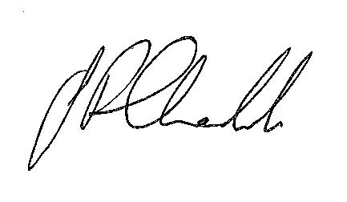
Mr Chadwick
Deputy Headteacher

Details of Pupil
Surname |  |  |  |  | Forename (s)
Address
Male/Female |  |  |  |  | Tutorial
Date of Birth |  |  |  |  | Condition/Illness
Medication
Name/Type of medication (as described on the container)
Duration of course of medication
Date dispensed
Full directions for use
Dosage/amount (as per instructions on container)
How often
Side Effects
Procedures to take in an emergency
Contact Information
Contact 1: |  |  |  |  | Contact 2:
Name |  |  |  |  | Name
Relationship to pupil |  |  |  |  | Relationship to pupil
Telephone number(s) |  |  |  |  | Telephone number(s)
GP Information
Name of GP |  |  |  |  | Telephone number
Allergies
I understand that I must deliver the medication personally to the school reception and accept that this is a service which the school is not obliged to undertake. I understand that it is my child’s responsibility to request their medication at the appropriate time.
Signature ……………………………………………………………(Parent/Carer) Date ………………………………
Signature ……………………………………………………………(Pupil Manager) Date ………………………………
Name of Medication: _________________________________________________________

Expiry Date: ________________________________________________________________

Quantity of Medication Received: _______________________________________________

Date | Time | Dose | Staff Name | Staff Signature

